SAFFCA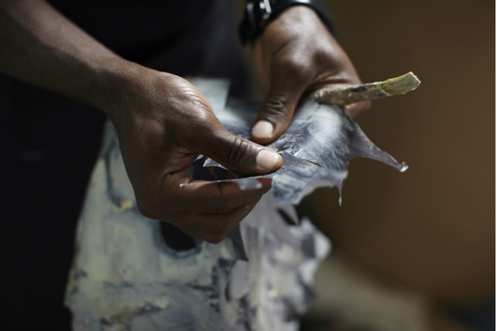 Our latest news:

SAFFCA NPC created in Johannesburg in 2015 – Southern African Foundation For Contemporary Art – and SAFFCA.EU created in Brussels in 2021 – Southern African Fellowship For Contemporary Art – are both operating under the generic name of SAFFCA – Southern African Foundation and Fellowship for Contemporary Art.

Our ‘Raison d’être’
Our tools
How to support us A word on Us
Our RESIDENCIES in Africa
in Europe
Our EVENTS in AFRICA
in EUROPE
Who,What,Where, When in AFRICA
in EUROPE
The SAFFCA Collection
For the love of BEING
Our Team in AFRICA
In EUROPE
Our AWARDS
Our additional INITIATIVES
Our PARTNERS in AFRICA
in EUROPE
Our ‘Raison d’être’
- share Art through love and passion
- participate in linking local to global
- diffuse, promote and support contemporary art and artists from Africa and Europe
- participate in the creation of new structures of dialogue between Africa and Europe through art

Our tools
- 20 to 30 crossed residencies yearly - an African artist and a European artist work and reside along one another for periods of 2 to 3 months in one of our 4 partnering locations in South Africa or at the LA CAMBRE Abbey in Brussels.
- Hosting 5 to 7 artists for 10 to 12 months in Studio at the Abbey.
- The biennial SEED event in Africa and the yearly SPRING, and FALL, SALON in Brussels.
- Presentations and exhibitions
- Partnerships

How to support us

Follow us on social media and share with your friends. Forward our newsletters to them and invite them to join us at our events

Africa: SAFFCA NPC – Investec Bank South Africa – 10011726468

Europe: The fund of the Friends of SAFFCA.EU is managed by ‘ Fondation Roi Baudouin ’.IBAN : BE10 0000 0000 0404 – communication: +++623/3705/80024+++
A word on Us
A word on SAFFCA,
the Southern African Foundation For Contemporary Art and its initiatives

Thanks to the artists, many Southern African and some European Contemporary Art Galleries, all our sponsors, partners and followers, SAFFCA is celebrating its tenth anniversary in 2025.

SAFFCA NPC was given birth in South Africa in 2015 to support contemporary creation, share art through love and passion and build bridges between the local and the global from Johannesburg and Saint Emilion, where a space was established in 2016.

SAFFCA.EU ASBL , the European arm of SAFFCA, officially opened its doors on 26 April 2022 in Brussels in partnership with ENSAV LA CAMBRE, the internationally renowned art school with close to a thousand students at any given time, to pursue its objectives and develop its initiatives in the heart of Europe. SAFFCA.EU is based at the LA CAMBRE Abbey under a tripartite agreement between the FWB (Brussels Region's public authority), ENSAV LA CAMBRE and SAFFCA.EU.

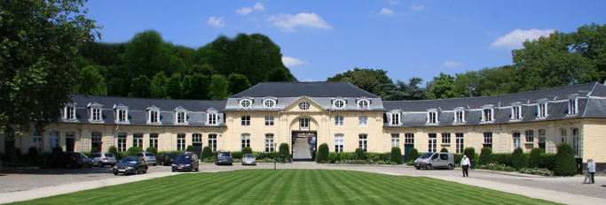

SAFFCA organises cross-residencies in Brussels and in 4 partnering locations in South Africa : Witklipfontein Eco Lodge in the Vredefort Dome, Entabeni Urban Farm in Knysna, Lion Sands of the More Collection near the Kruger Park and at the residency space of Gallery MOMO in Johannesburg. ( A fifth South African residency location should open in Cape Town in late 2025 or in early 2026 as well as a second location in Belgium in the natural country area of Graide ). For most of the residencies, an African artist works alongside a European artist for periods of 10 to 12 weeks. ( We also create sometimes fully African residencies in South Africa, believing in the importance of multicultural conversations in between African communities or countries )

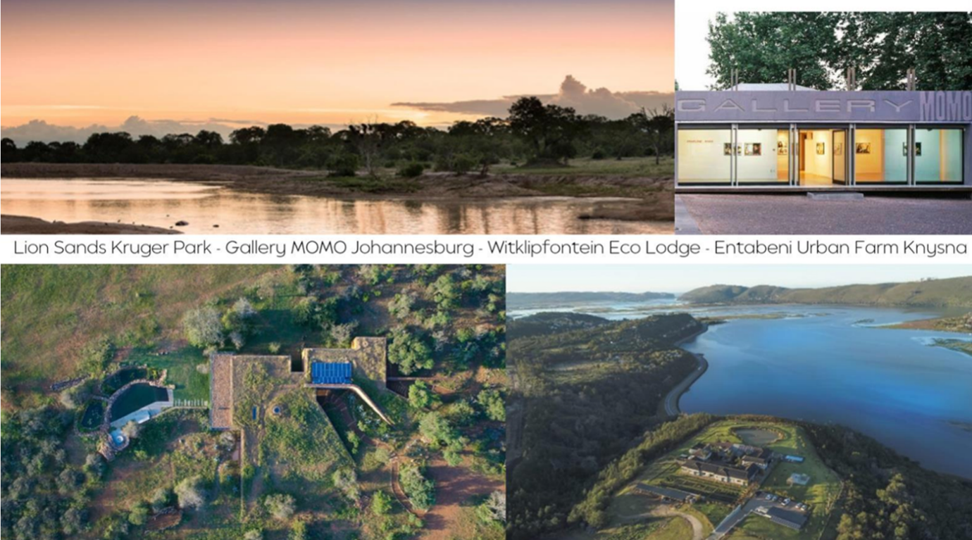

In addition, SAFFCA.EU is inviting 3 artists who have completed their master's at ENSAV LA CAMBRE and 2 other artists who are slightly further in their career to work in their own studio space at SAFFCA.EU in the Abbey for periods of 10 months from September to June. The studio space is offered free of charge to these artists, who come from various origins and backgrounds but live in Brussels.

Through its various initiatives, SAFFCA promotes the development of multicultural dialogues focused on the art practice and participates in the erection of a new structure or framework for intercontinental communication between communities and diverse artistic ecosystems.

To actively participate in our own fundraising while offering exposure to emerging and often unrepresented artists next to established or even famous artists in prestigious spaces, we organize SEED every second year in Johannesburg at the Villa Arcadia in Parktown and two SALONS every year in Brussels at the Abbey. All these events are a true celebration of the wealth and the diversity of the contemporary creation on both continents.

At our SALONS, we present 10 to 12 artists, both established and emerging from the local but cosmopolite contemporary scene and help to promote them in the prestigious setting of the LA CAMBRE Abbey. The artists donate 40% of the price of their works to support SAFFCA.EU's initiatives and offer buyers the opportunity to make this donation on their behalf. If officially represented by a Gallery, the artists offer 10 % of the price and SAFFCA.EU contributes 7.5 % to the gallery towards their admin and logistic costs. ( All amounts are VAT included where applicable. )

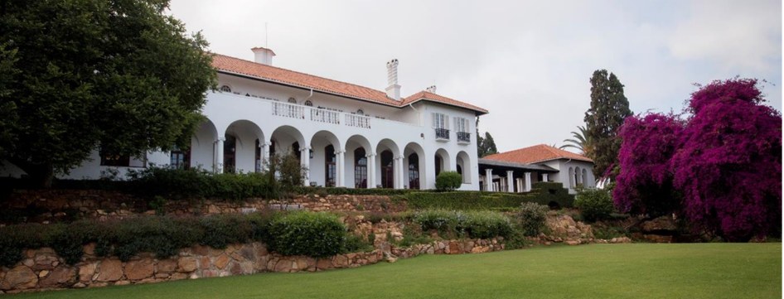

At SEED, the third edition of which took place in October 2024, we present around 60 works by 60 renowned, established and emerging African artists represented by a gallery or independent. The artists receive 50 or 60% ( depending on whether they are represented or not ) of the proceeds from the sale of their work. 9 % is shared between three nonprofit art organizations ( The Centre For The Less Good Idea, The Bag Factory and META Foundation ) and 30% supports some of SAFFCA’s initiatives. ( All amounts are VAT included where applicable.)

Every year, we are offering 20 to 25 residencies in Africa and 6 residencies in Europe in addition to welcoming 5 to 6 artists in studio in Brussels for a period of 10 to 12 months.

SAFFCA is furthermore partnering:

- LATITUDES for the ANNA Award
- META Foundation for the VUSA award following the CONTRA event.
- LA CAMBRE for the SAFFCA Award at the Graduation
- ARBA for the SAFFCA Award at the time of ART-BRUSSELS

info@saffca.com

Our RESIDENCIES in Africa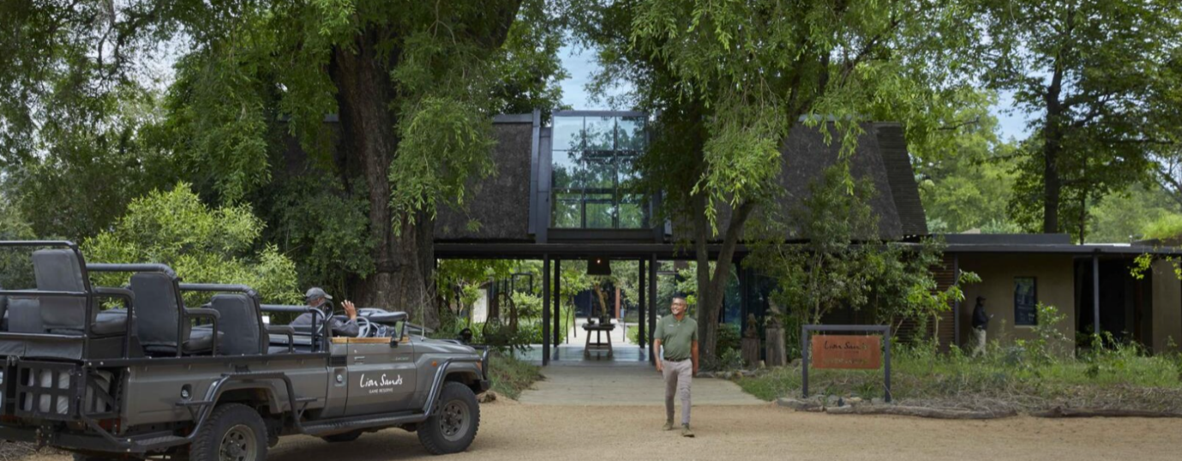


www.lionsands.com

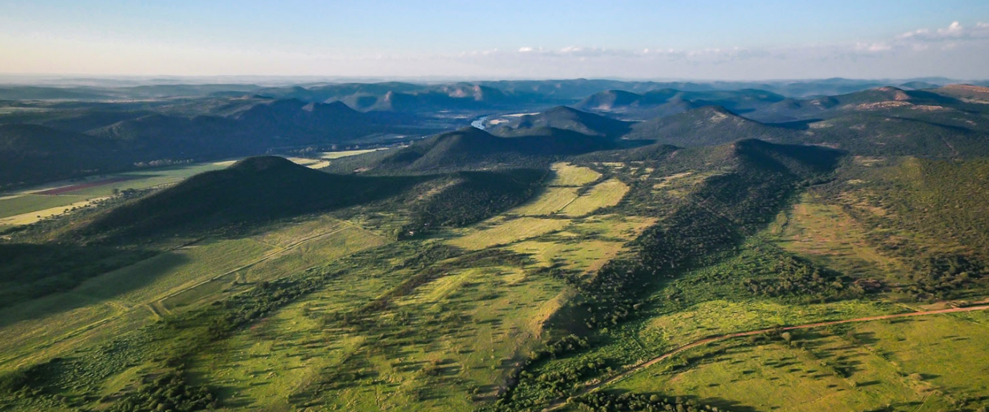



www.Witklipftontein.co.za

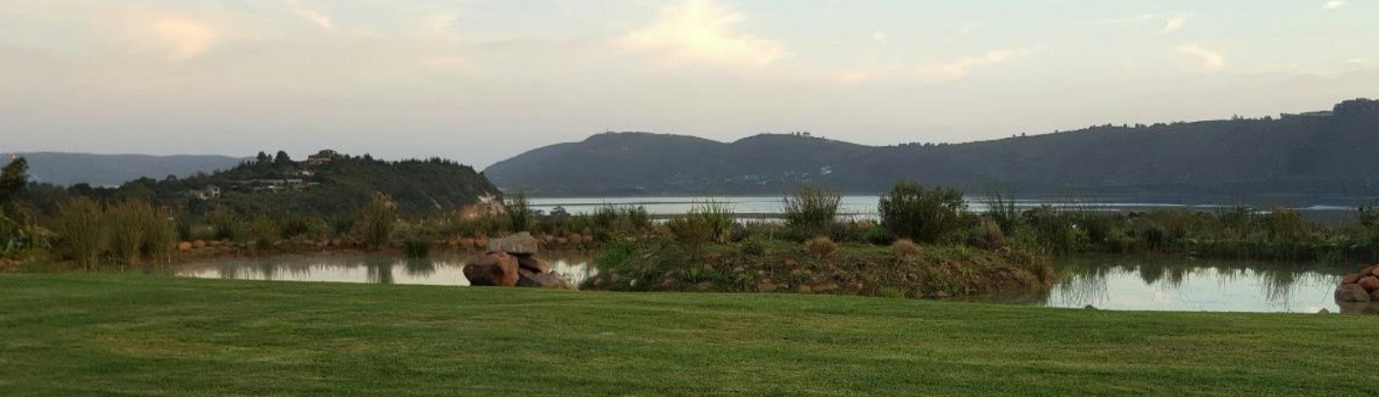

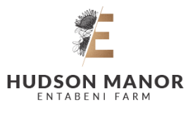
www.hudsonmanorknysna.com

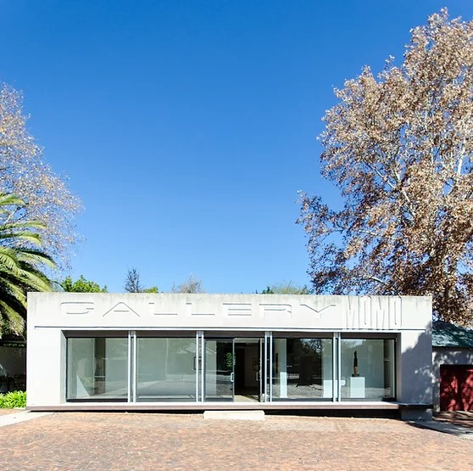


www.gallerymomo.com
Our RESIDENCIES in Europe

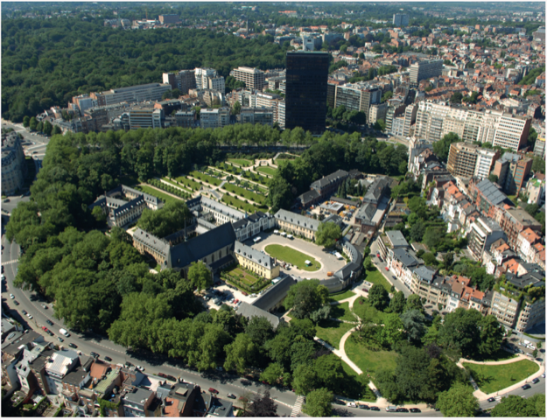
LA CAMBRE Abbey
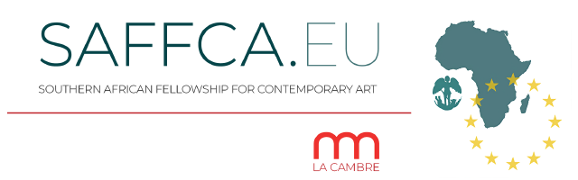
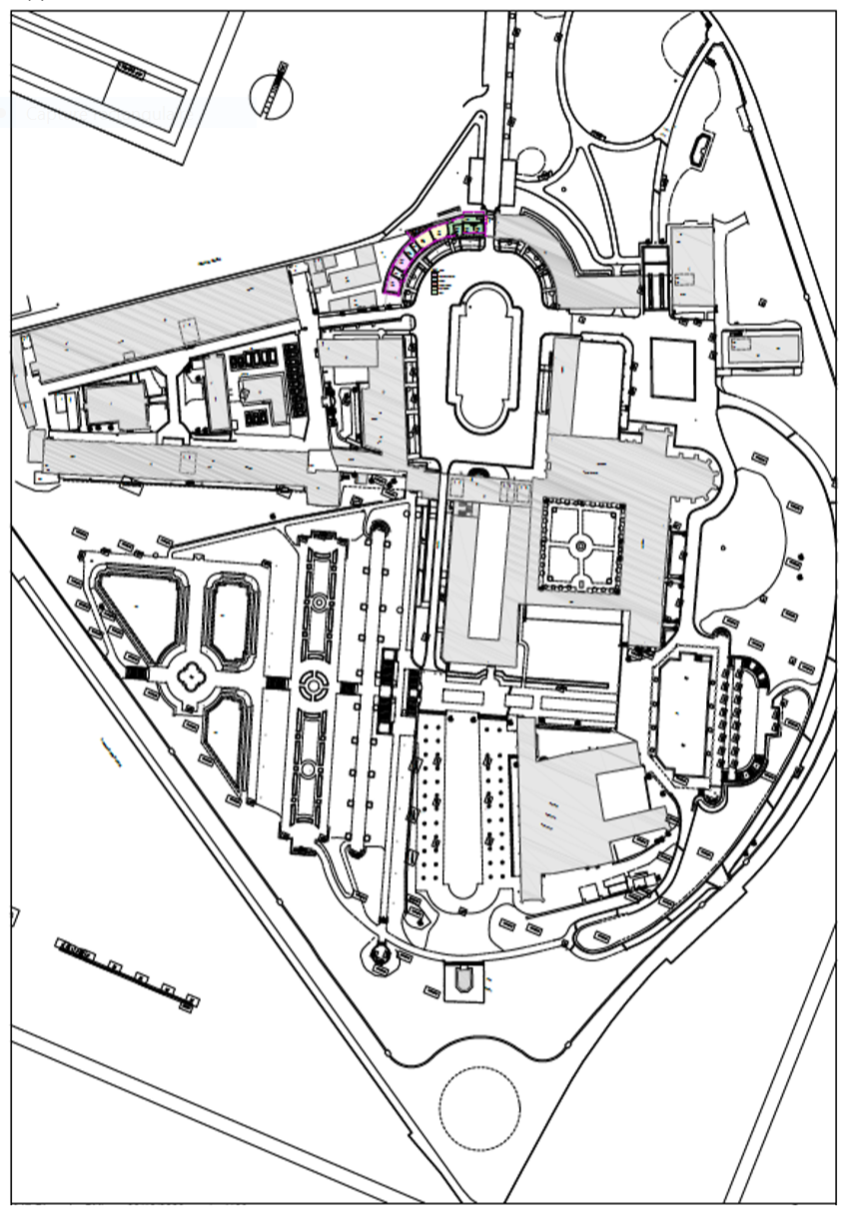
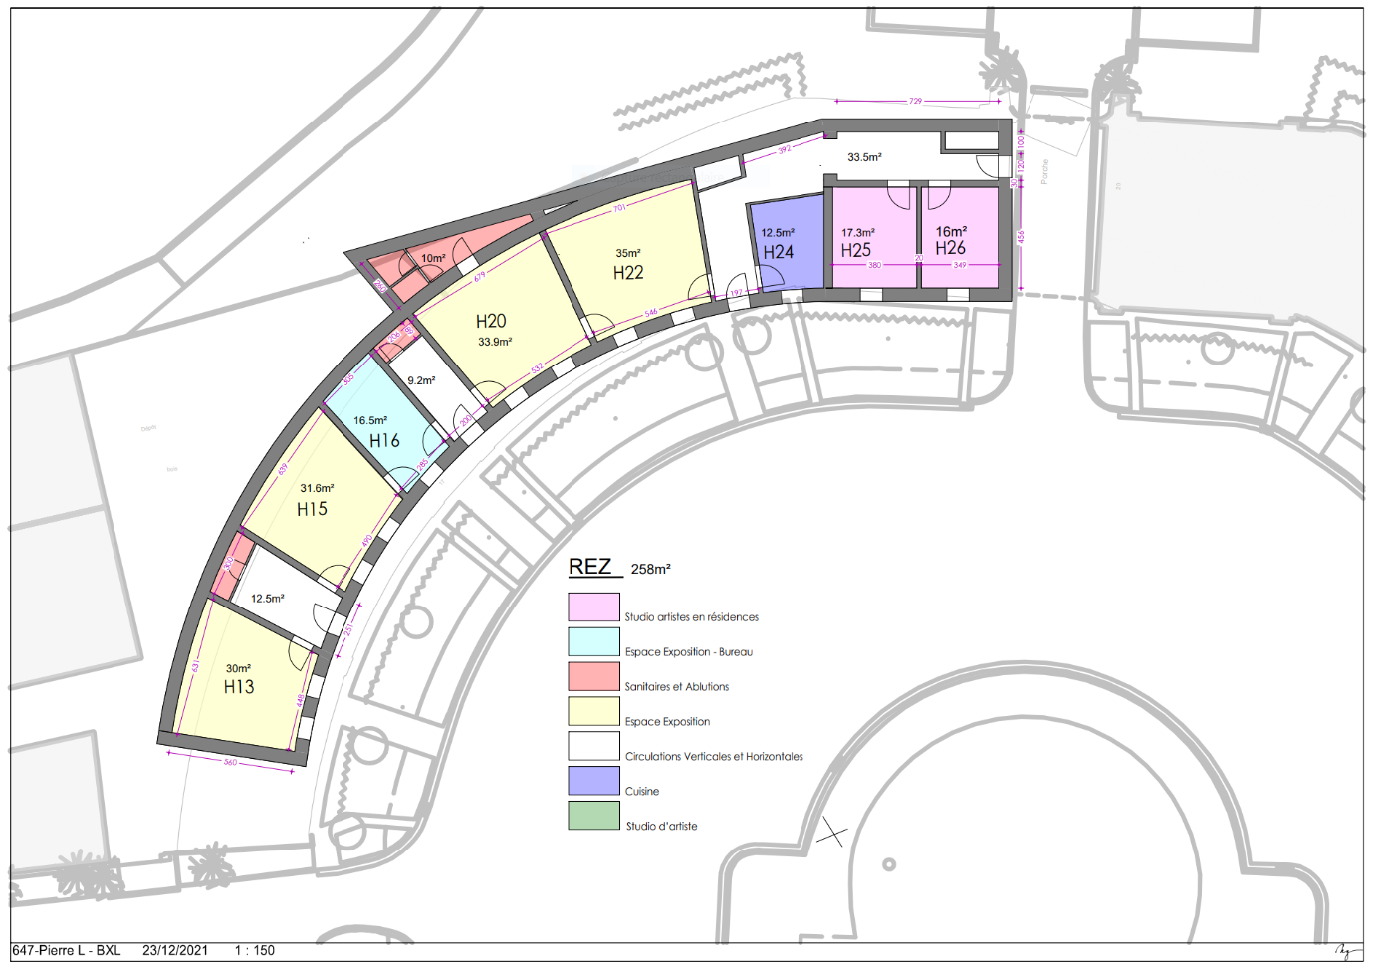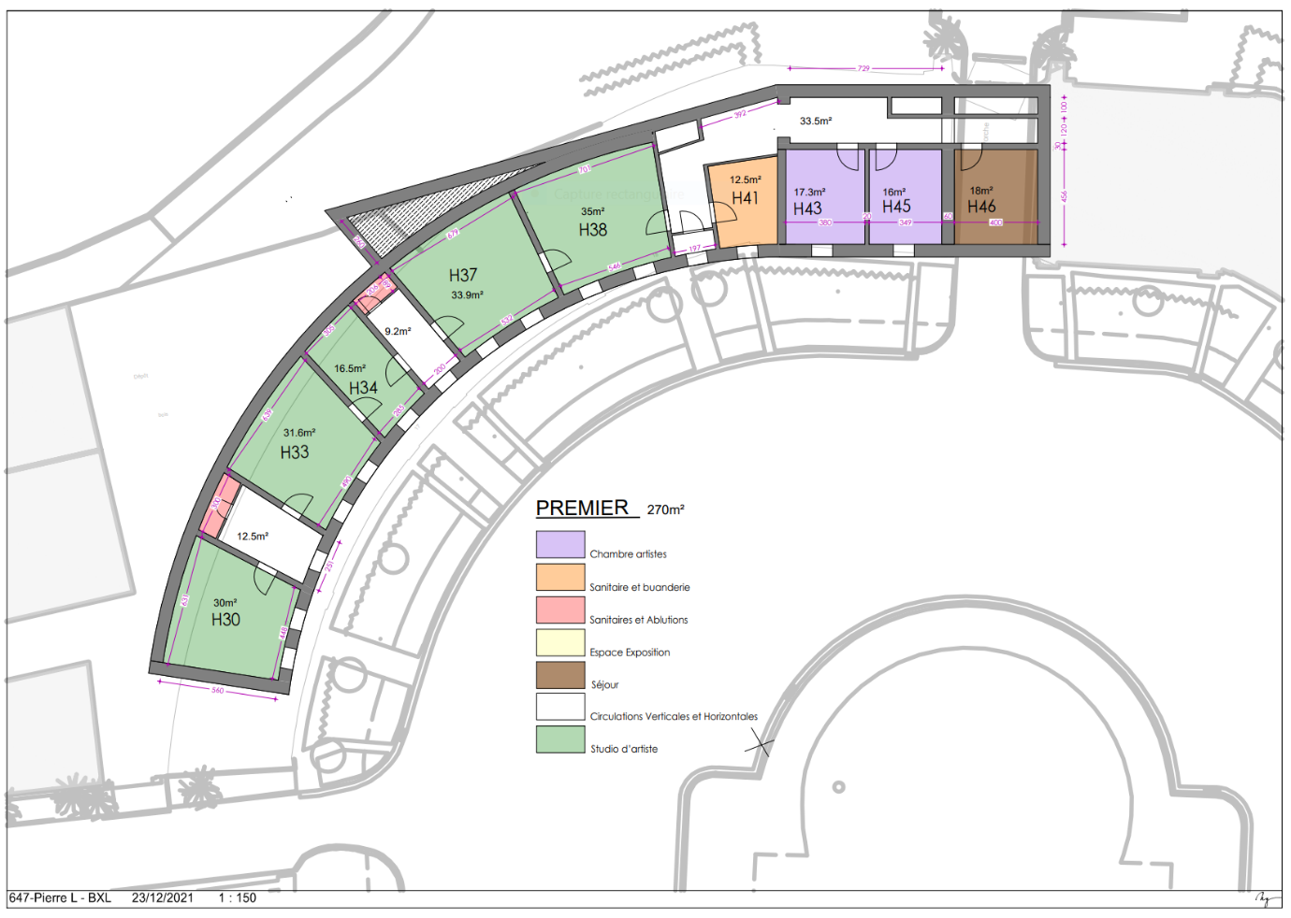

Our EVENTS
in AFRICA

SEED I
SEED II
SEEDIII
Our EVENTS
in EUROPE

SAFFCA SPRING SALON 2023

SAFFCA SPRING SALON 2024

SAFFCA SPRING SALON 2025

SAFFCA FALL SALON 2023
SAFFCA FALL SALON 2024
SAFFCA FALL SALON 2025
Who,What,Where, When in AFRICA

Who,What,Where, When in EUROPE

SAFFCA Collection

For the love of BEING

Our Team
In AFRICA
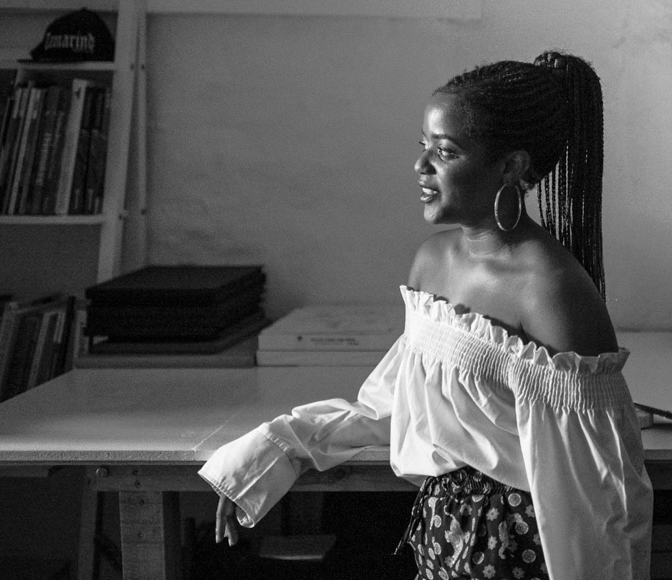

RUWADZANO RUSIKE
Ruzy Rusike is a South African curator and researcher with over a decade of experience in the arts and cultural sector. Her work spans curatorship, cultural management, research, and public engagement, with a strong focus on African modernism, historical representation, and the role of care within curatorial practice.
Since completing her undergraduate studies in Fine Arts at the University of the Witwatersrand in 2014, Ruzy has built a dynamic career grounded in research-led methodologies and collaborative, cross-cultural exchange. She went on to complete an Honours in Curatorship at the University of Cape Town’s Michaelis School of Fine Art (2017) and is currently completing a Master’s in Anthropology and Museum Practice at Goldsmiths, University of London (2024–2025)
.
Ruzy has curated significant solo and group exhibitions across South Africa and internationally, including Azibuyele Emasisweni – Return to the Source by Pitika Ntuli, which won the Global Fine Art Awards People’s Choice “You-2” Award, and Esther Mahlangu 85, in celebration of Dr. Esther Mahlangu’s work in South Africa. Her curatorial projects have been staged at the Venice Biennale, Oliewenhuis Art Museum, and The Melrose Gallery, where she worked for 5 years as Head Curator.
Previously, she held the role of Head of Communication and Curator at the Southern African Foundation for Contemporary Art (SAFFCA), where she led initiatives connecting artists and institutions across South Africa and France. She has also worked with a range of organisations, from Gallery MOMO and Assemblage to the French Ministry of Culture, developing strategies for cultural access, interpretation, and public engagement.
Throughout her practice, Ruzy draws on African epistemologies to rethink how time, history, and knowledge circulate within museums and cultural institutions. Her curatorial philosophy is shaped by care, collectivity, and an ongoing commitment to unlearning inherited systems of display and authority.
She has contributed to artist monographs, heritage exhibitions, and educational programmes that challenge conventional forms of representation and encourage inclusive, multi-vocal storytelling. Ruzy’s work continues to explore how curatorial practice can become a space for memory work, repair, and imagination towards connecting communities, histories, and futures across geographies.

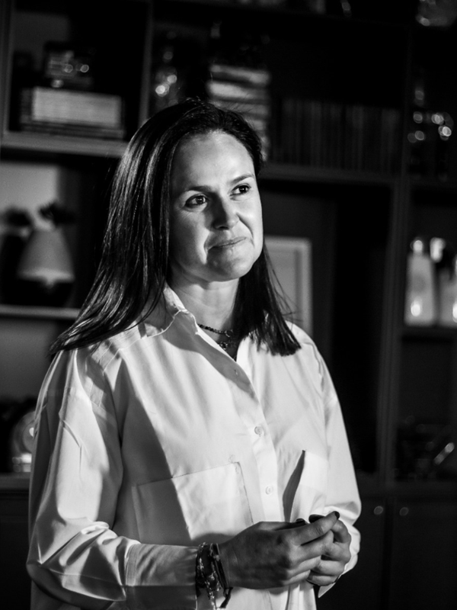

NICOLA BIRD

Nicola is an experienced corporate finance and investment banking executive with over 20 years of leadership and advisory expertise across M&A, private equity, and venture capital. Proven track record of managing high-value transactions, advising top-tier clients, and driving strategic growth in both corporate and family office settings. Extensive experience in executing complex deals in South Africa and globally, with a passion for developing emerging markets and entrepreneurial ventures.
Nicola is currently managing numerous entrepreneurial ventures and investments and currently evaluating numerous strategic growth opportunities.
As well as being registered as a Chartered Accountant in South Africa, she is further qualified as a Chartered Financial Analyst.



- Director of Strategic Transactions and New Business Sales for SSADirector of Strategic Transactions and New Business Sales for SSA Google · Full-timeGoogle · Full-timeApr 2025 - Present

Deal Structuring, Business Advisory Services and +4 skills

- Director
Bird and Company 2013 - Mar 2025

Financial Advisory, Private Equity and +18 skills



Executive Director
J.P. Morgan · Full-time Jan 2001 - Dec 2013
Financial Advisory, Structured Finance and +15 skills



ManagerManager
Deloitte · Full-timeDeloitte · Full-timeJan 1998 - Dec 2000 ·

Financial Advisory, Board of Directors and +5 skills

. 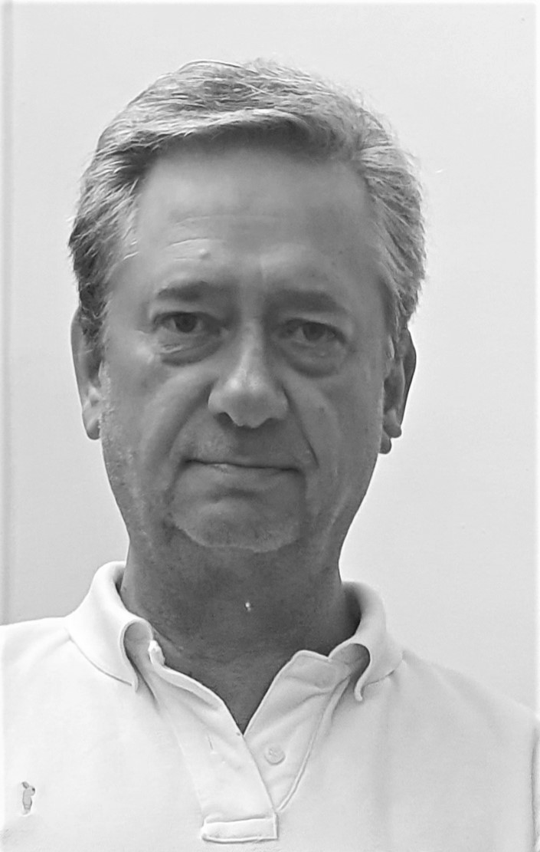
PIERRE LOMBART
Born in Brussels in January 1959, Pierre arrived in Southern Africa after completing his studies in Architecture in the European capital. He worked for 34 years at GLH ARCHITECTS; following a medical incident, Pierre left his position as Senior Partner to serve as Honorary Chairman.
In this way, Pierre continues to contribute to the design work of large-scale or unique projects, while maintaining the privileged relationships based on mutual trust that he has built throughout his career with numerous clients. GLH is often entrusted with major commercial and residential projects and is notably responsible for the headquarters of three of South Africa’s four largest banks—Standard Bank, Nedbank, and ABSA—as well as most of the offices and various facilities for VODACOM, the equivalent of Proximus in Belgium or Orange in France.
From the age of 10, Pierre discovered an interest in art, which quickly grew into a passion. He has supported contemporary creation in Southern Africa for the past thirty years. He was the first person from the African continent to be invited to join the friends of documenta before being asked to join the friends of the Centre Pompidou in Paris.
Pierre is the co-founder of SAFFCA NPC (Southern African Foundation For Contemporary Art) in Africa and the co-founder / president of SAFFCA.EU ASBL (Southern African Fellowship For Contemporary Art) in Brussels, where he settled with his family in January 2021.
Officially opened in April 2022, SAFFCA.EU is in partnership with ENSAV LA CAMBRE and operates from a space in the Abbaye de la Cambre overlooking its main courtyard.
In addition to the joys of family life with his spouse and children, Pierre enjoys the immense privilege of being deeply driven by his passion, the sharing of his love for art.

Our Team
In EUROPE
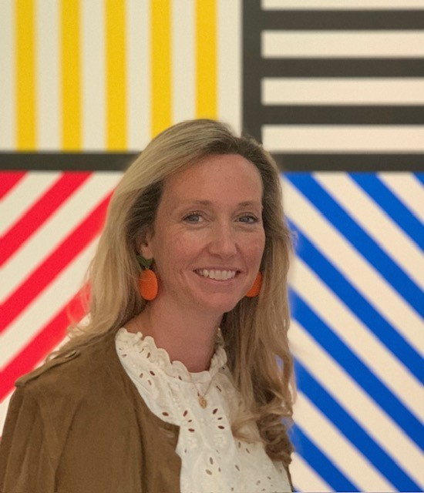
KATE FELLENS

Born in 1982 in Boston - USA, Kate is a lover of the arts and of South Africa. She has spent her entire career involved with auction houses worldwide and is head of International Business Development for Strauss & Co, helping to educate and promote art and artists of Southern Africa.
Kate is co-founder of SAFFCA.eu, an artist residency program based in Brussels which hosts a joint residency program for African-based artists to work in parallel with European-based artists in cultural exchange.
Kate double majored in Art History and French Studies at Williams College, Massachusetts and began her career at Christie’s in New York. She moved to Paris to complete a post-graduate degree through Christie’s Education and joined the Christie’s Paris team. Her interest in corporate collections and art funds grew during this time and her thesis was written on art as an investable asset class and portfolio diversification.
A further move to London saw Kate join Barclay’s Private Bank, in a team focused on High Net Worth Individuals. Kate brought an art advisory expertise to the financial institutions team. However, her desire to be closer to the art works themselves saw her return to Christie’s, where she spent the next 7 years in London focusing on Client Development department with the Impressionist and Post War & Contemporary departments. Kate is privileged to have worked on a number of important sales, including the The C. Ruxton and Audrey B. Love Collection, The Collection of Yves Saint Laurent and Pierre Bergé hosted at the Grand Palais in Paris, and the re-creation of Truman Capote’s famed 1966 Black and White ball for an auction benefiting New York’s famed Plaza Hotel.
Kate has since lived in Nairobi, Kenya and Johannesburg, South Africa, for over 5 years, where her passion for Africa was born. She was a panel judge at the Art Fair in Nairobi and completed art-related business development projects in East Africa. She is fortunate to have been able to combine her two great passions, art and Africa, and works to promote the arts from the continent and the brand of Strauss abroad. Some highlight of Kate’s career with Strauss includes the auction of Pierneef’s Farm Jonkershoek with Twin Peaks Beyond, Stellenbosch for over r20 million / GBP1 million which highlighted a dialogue between South Africa and Europe through the artists travels, something that Kate is keen to explore. Secondly, the sale of Williams Kentridge’s 2 set design for the band Mango Groove’s Another Country, which sold for r5 million / GBP250,000 approx., was an equally profound experience.
Kate is fluent in English and French and is currently based in Brussels, with her husband and two young daughters. Beyond promoting the arts of Africa, Kate is equally interested in exposing children to art and has championed the family brunch viewings and children’s art tours at Strauss and SAFFCA.
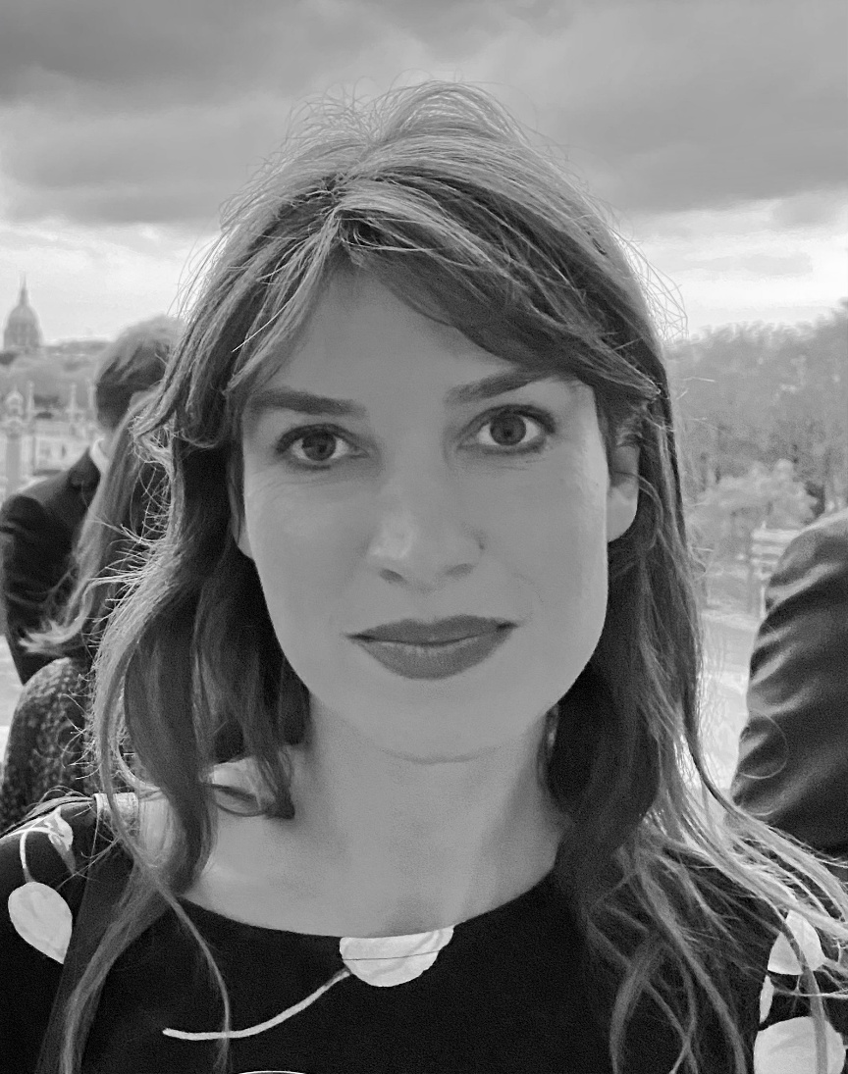

VALENTINE HIMPENS-DAVID

Born in Lille (France) in 1992, Valentine Himpens-David is an independent curator with a Master’s degree in Exhibition Practice from the Royal Academy of Fine Arts in Brussels.
For several years, she has been designing and coordinating exhibitions that actively support emerging contemporary creation, in collaboration with art centers, private collections, universities, and galleries. She has notably worked with the Centrale for Contemporary Art, the Proximus Art Collection, ETE78, Kunstraum, Université Libre de Bruxelles, Vrije Universiteit Brussel, and Contretype ASBL.
Passionate about art and its transmission, she has given lectures for Jeunesse et Arts Plastiques at BOZAR and has taught at ENSAV La Cambre as well as at the Royal Academy of Fine Arts in Brussels.
After serving as Head of Public Relations at La Cambre, she is now a member of the Visual Arts Commission of the Wallonia-Brussels Federation and sits on the board of SAFFCA.
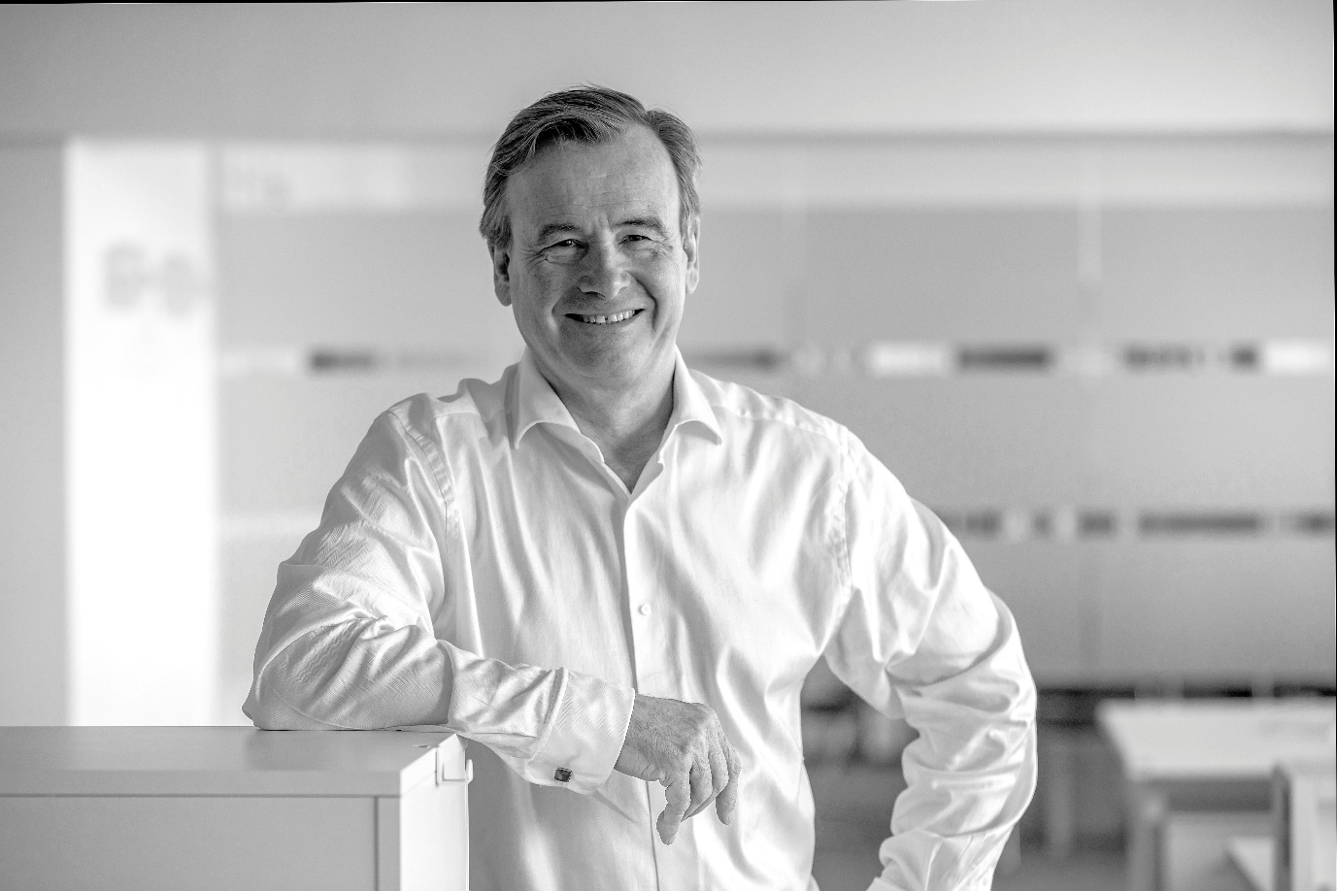
LUC DE TILLESSE

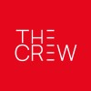

The Crew The Crew
21 yrs 7 mos21 yrs 7 mos

CEOCEO
Jan 2021 - Present · 4 yrs 7 mosJan 2021 to Present · 4 yrs 7 mosBrusselsBrussels

Co-Managing DirectorCo-Managing Director
Jan 2004 - Present · 21 yrs 7 mosJan 2004 to Present · 21 yrs 7 mos

Founder Co-Managing DirectorFounder Co-Managing Director
2004 - Present · 21 yrs 7 mos2004 to Present · 21 yrs 7 mos

      - 2004 - Present: The Crew Communication
Founder Co-Managing Director
Communication agency specialized in corporate & financial communication.
Implementation of a strategy entirely focused on corporate communication.
Development of a research department "The Crew Research".
Gained many new customers: Solvay Group, Total, Sofina, Solvac, Q8, Assuralia, ...2004 - Present: The Crew Communication Founder Co-Managing Director Communication agency specialized in corporate & financial communication. Implementation of a strategy entirely focused on corporate communication. Development of a research department "The Crew Research". Gained many new customers: Solvay Group, Total, Sofina, Solvac, Q8, Assuralia, ...…see more



Managing PartnerManaging Partner
Red CellRed Cell1998 - 2004 · 6 yrs1998 to 2004 · 6 yrs

    - Responsible for the development of the agency.
Implementation of the group's new strategy.
Winning many new businesses: CBR, Total, Fortis AG, Imperial, Alfa Romeo, Eurogentec, WinBooks, Parc d'Aventures Scientifiques, IDT, Cash Converters,...
Strengthening relations and winning numerous institutional budgets: Office of the Minister of the Budget (Johan Vande Lanotte), Office of the Minister of Employment (Laurette Onkelinx), Office of the Minister of Finance (Didier Reynders), Office of the Minister of Mobility (Isabelle Durant), Ministry of the Brussels Region (Robert Delathouwer, François-Xavier de Donnea, Willem Draps), State Secretary for Energy (Olivier Deleuze),...
1998: Sale of 100% of O.T.S. shares to the WPP group (the world's leading communication group).
Responsible for the development of the agency. Implementation of the group's new strategy. Winning many new businesses: CBR, Total, Fortis AG, Imperial, Alfa Romeo, Eurogentec, WinBooks, Parc d'Aventures Scientifiques, IDT, Cash Converters,... Strengthening relations and winning numerous institutional budgets: Office of the Minister of the Budget (Johan Vande Lanotte), Office of the Minister of Employment (Laurette Onkelinx), Office of the Minister of Finance (Didier Reynders), Office of the Minister of Mobility (Isabelle Durant), Ministry of the Brussels Region (Robert Delathouwer, François-Xavier de Donnea, Willem Draps), State Secretary for Energy (Olivier Deleuze),... 1998: Sale of 100% of O.T.S. shares to the WPP group (the world's leading communication group). …see more

Managing Director / Partner

Managing Director / PartnerManaging Director / Partner
O.T.S. Obliged To SeeO.T.S. Obliged To See1995 - 1998 · 3 yrs1995 to 1998 · 3 yrs

    - Director of the Board of Directors
Responsible for the development of the agency.
Mission to seek partners and/or sales of the company to an international group.
1995: Search for new challenges and association at the level of
50% of the O.T.S. communication agencyDirector of the Board of Directors Responsible for the development of the agency. Mission to seek partners and/or sales of the company to an international group. 1995: Search for new challenges and association at the level of 50% of the O.T.S. communication agency…see more

European Coordinator/Member of the McCann Board

European Coordinator/Member of the McCann BoardEuropean Coordinator/Member of the McCann Board
Mc Cann EricksonMc Cann Erickson1980 - 1994 · 14 yrs1980 to 1994 · 14 yrs

    - European Coordinator/Member of the McCann Board
1991: European Coordinator: Interbrew Europe (Stella Artois, Leffe, Hoegaarden), Eurocheque International.
1990: Client Service Director: Nestlé Benelux, RJR Reynolds Tobacco, Interbrew, Columbia Pictures, International Numismatic Management.
1988: Account Director: Imperial, Martini & Rossi, Zurich Insurance, RJR Reynolds.
1986: Account Manager: Imperial, Martini & Rossi (Rosso, Bianco, Dry, William Lawson's, Port Offley, Pastis Duval, Laurent Perrier), launch of Swatch watches, Accord Group, Nestlé Group.
1984: Senior Account Executive: Imperial, Krups, Texas Instruments, Martini & Rossi.
1981: Account Executive: Imperial, Krups, Levi's Europe.
1980: Junior Account Executive: Imperial, Krups.
European Coordinator/Member of the McCann Board 1991: European Coordinator: Interbrew Europe (Stella Artois, Leffe, Hoegaarden), Eurocheque International. 1990: Client Service Director: Nestlé Benelux, RJR Reynolds Tobacco, Interbrew, Columbia Pictures, International Numismatic Management. 1988: Account Director: Imperial, Martini & Rossi, Zurich Insurance, RJR Reynolds. 1986: Account Manager: Imperial, Martini & Rossi (Rosso, Bianco, Dry, William Lawson's, Port Offley, Pastis Duval, Laurent Perrier), launch of Swatch watches, Accord Group, Nestlé Group. 1984: Senior Account Executive: Imperial, Krups, Texas Instruments, Martini & Rossi. 1981: Account Executive: Imperial, Krups, Levi's Europe. 1980: Junior Account Executive: Imperial, Krups. …see more

EducationEducation

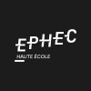

EPHECEPHEC

Ecole artistique Saint Luc Tournai

Ecole artistique Saint Luc TournaiEcole artistique Saint Luc Tournai
Master's degree, Art, études d''art, généralMaster's degree, Art, études d''art, général

MiscellaneousMiscellaneous

6 months intensive training on strategy and management in Helsinki. Numerous cursus & seminars in New York and London : focus on strategic planning, management, team spirit, financial goals,…

VolunteeringVolunteering

- Director
Van Buuren MuseumVan Buuren MuseumJan 2015 - Present · 10 yrs 7 mosJan 2015 - Present · 10 yrs 7 mos

- Director
Director
European Space for SculptureEuropean Space for SculptureJan 2016 - Present · 9 yrs 7 mosJan 2016 - Present · 9 yrs 7 mos

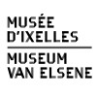

Director of the Friends of the Musée d'IxellesDirector of the Friends of the Musée d'Ixelles
Musée d'Ixelles - Museum van ElseneMusée d'Ixelles - Museum van ElseneJan 2000 - Jan 2014 · 14 yrsJan 2000 - Jan 2014 · 14 yrs

- Member of the Art Society Committee
Member of the Art Society Committee Member of the Art Society Committee
ART SOCIETYART SOCIETYJan 2010 - Jan 2016 · 6 yrsJan 2010 - Jan 2016 · 6 yrs
  - The Art Society is a unique members’ organisation for amateurs and collectors of contemporary art, an exchange platform for meeting likeminded people and discussing each other’s interests. To experience contemporary art is about being there at the right time and living it as it happens. The Art Society organizes one exclusive event every month: visits of artists’ studios, private or corporate collections, one- or multi-day foreign trips, visits in preview to museums and galleries, conferences…

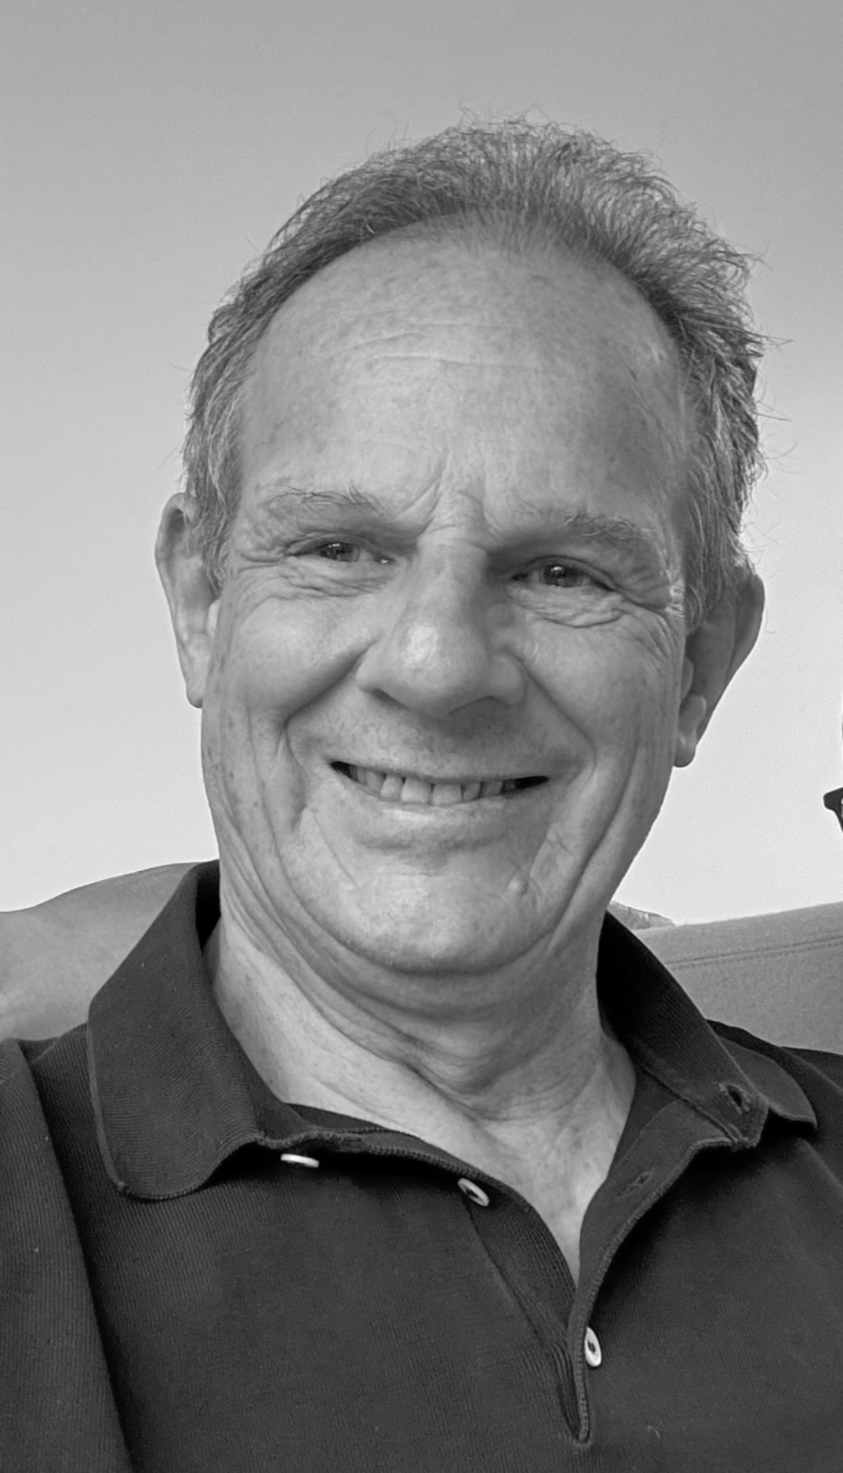

JOACHIM VON BEUST

Né 19 février 1952 à Stuttgart en Allemagne
EDUCATION
1959 - 1970 Ecole à Stuttgart et à Heidelberg
1971 - 1972 Grossengstingen (Allemagne)
Service militaire 16 mois
1972 Romeike & Curtice, Londres
Stage de 6 mois
Media-Monitoring, International PR Planning
1973 Handelsblatt, Düsseldorf
Stage 1 an
Toutes les activités du Journal financier et économique allemand
1974 -1978 Universität Mannheim
Betriebswirtschaft
Spécialisiation Revision et Treuhand
MBA
Depuis 9/1978 Auxipress, Bruxelles
Directeur et actionnaire majoritaire
Leader du marché de Media Monitoring presse-radio-tv, medias sociaux et analyses, Media Intelligence,
en Belgique
1982 - 2004 Observer Argus Media, Stuttgart-Berlin
CEO et actionnaire majoritaire
Leader du marché allemand comme acteur principal complet en analyses de médias presse-radio-tv
1988 - 1977 FIBEP,
Vice-Président et Président
Fédération Internationale de la représentation des entreprises de media monitoring et analyses dans le monde entier
2008 - 2014 FIBEP
Secrétaire Général
2004 - 2009 Wines and Dreams
CEO et actionnaire majoritaire
Distribution de vins en Espagne
2018 - Kunstraum
Fondation d'un espace d'art à Bruxelles (Uccle) pour la promotion d'artistes émergents contemporains (www.kunstraum.art)
2021 - SAFFCA
Membre fondateur de l'association de soutien et de promotion d'artistes, Bruxelles
Promotion et échange d'artistes entre Europe et Afrique
JOACHIM VON BEUST
Born February 19, 1952 in Stuttgart, Germany
EDUCATION
1959 - 1970 School in Stuttgart and Heidelberg
1971 - 1972 Grossengstingen (Germany) - Military service, 16 months
1972 Romeike & Curtice, London
6-month internship - Media Monitoring, International PR Planning
1973 Handelsblatt, Düsseldorf
1-year internship - All activities of the German financial and business newspaper
1974 - 1978 University of Mannheim - Business Administration
Specialization in Auditing and Trusteeship - MBA
Since 9/1978 Auxipress, Brussels
Director and majority shareholder
Market leader in media monitoring print-radio-tv, social media and analysis, Media Intelligence, in Belgium
1982 - 2004 Observer Argus Media, Stuttgart-Berlin - CEO and majority shareholder
Market leader in Germany as a leading full-service provider in press-radio-tv media analysis
1988 - 1997 FIBEP, - Vice President and President
International Federation representing media monitoring and analysis companies worldwide
2008 - 2014 FIBEP - Secretary General
2004 - 2009 Wines and Dreams
CEO and majority shareholder - Wine distribution in Spain
2018 - Kunstraum
Founded an art space in Brussels (Uccle) for the promotion of emerging contemporary artists (www.kunstraum.art)
2021 - SAFFCA
Founding member of the association for the support and promotion of artists, Brussels
Promotion and exchange of artists between Europe and Africa

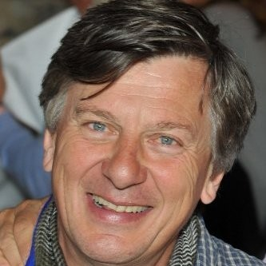

GODEFROID DE WOELMONT

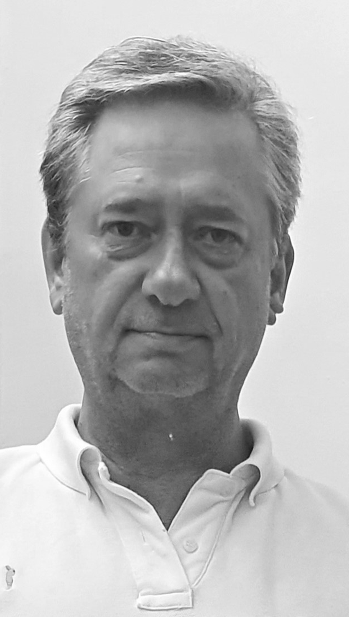
PIERRE LOMBART

Born in Brussels in January 1959, Pierre arrived in Southern Africa after completing his studies in Architecture in the European capital. He worked for 34 years at GLH ARCHITECTS; following a medical incident, Pierre left his position as Senior Partner to serve as Honorary Chairman.
In this way, Pierre continues to contribute to the design work of large-scale or unique projects, while maintaining the privileged relationships based on mutual trust that he has built throughout his career with numerous clients. GLH is often entrusted with major commercial and residential projects and is notably responsible for the headquarters of three of South Africa’s four largest banks—Standard Bank, Nedbank, and ABSA—as well as most of the offices and various facilities for VODACOM, the equivalent of Proximus in Belgium or Orange in France.
From the age of 10, Pierre discovered an interest in art, which quickly grew into a passion. He has supported contemporary creation in Southern Africa for the past thirty years. He was the first person from the African continent to be invited to join the friends of documenta before being asked to join the friends of the Centre Pompidou in Paris.
Pierre is the co-founder of SAFFCA NPC (Southern African Foundation For Contemporary Art) in Africa and the co-founder / president of SAFFCA.EU ASBL (Southern African Fellowship For Contemporary Art) in Brussels, where he settled with his family in January 2021.
Officially opened in April 2022, SAFFCA.EU is in partnership with ENSAV LA CAMBRE and operates from a space in the Abbaye de la Cambre overlooking its main courtyard.
In addition to the joys of family life with his spouse and children, Pierre enjoys the immense privilege of being deeply driven by his passion, the sharing of his love for art.

The founding members of
The FRIENDS of SAFFCA.EU

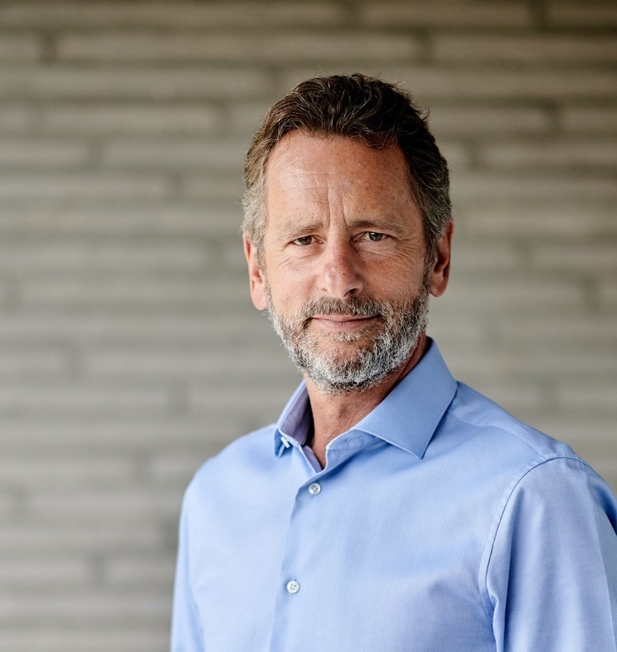
BRUNO ERPICUM
Architect Bruno Erpicum practices his craft both in Brussels, where his office is located, and abroad.
The architecture he has developed skillfully takes advantage of environmental constraints, which he considers essential to the design process: “Designing what is to be built is above all about listening to all the elements of the site destined to receive the construction. Like a sculpture, the building occupies space; it also has the privilege of being experienced from within. It is therefore up to us to orchestrate forces, materials, volumes, and light so that, in addition to providing an appropriate response to the needs that guide the design, the experience of the space brings about an emotion.”
Whether in an urban setting, such as London where he notably built the Dalí Museum, or in the Balearic countryside, he has managed to render his interventions unique, in complete freedom, giving rise to contemporary architecture with great sensitivity.
‘It is all about exchange, reflection, and transmission through the practice of art. Sharing Pierre's enthusiasm and passion seemed obvious to me. Each event brings its own discoveries through geographical and cultural cross-pollination. I warmly invite you to join us.’
Bruno ERPICUM : Co-founding member of th"Fonds des Amis de Saffca.eu auprès de la Fondation Roi Baudouin »

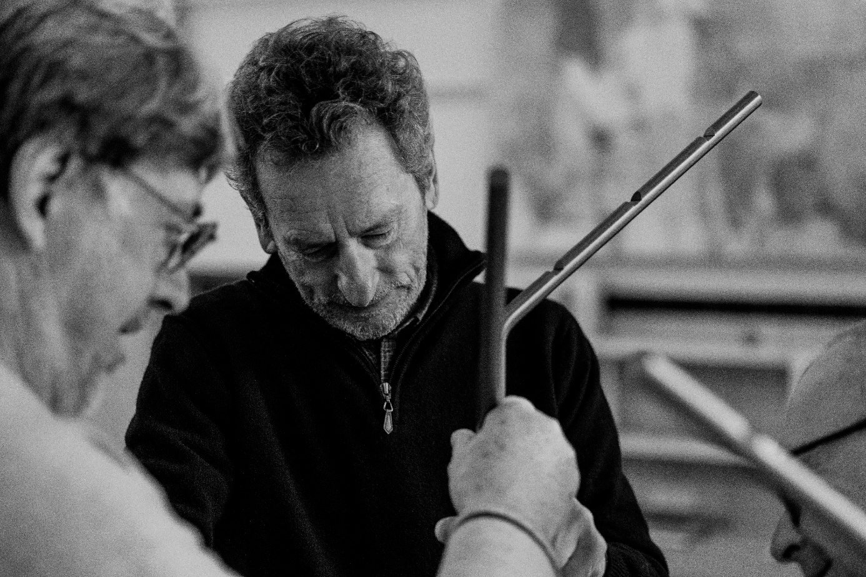
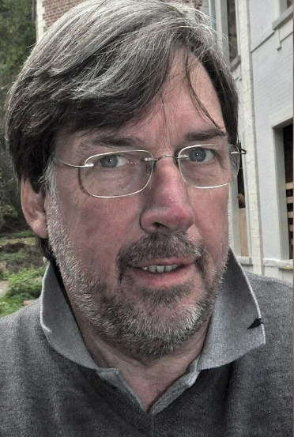

ANDRE VOSSEN
Since my early years, I have been passionate about art, design, and architecture.
Throughout my professional life, I have had the privilege of working in what is known as the “design” field.
In 1981, together with Viviane, my spouse (who shares all our passions!), we founded a company to distribute contemporary furniture and lighting fields in which we had already been active for many years. This allowed us to work alongside renowned designers such as Tobia Scarpa, Toshiyuki Kita, Carlo Forcolini, Michele de Lucchi, Christophe Gevers, and many others.
Several of these companions have given lectures in our beautiful space: the former dairy in Hoegaarden.
Later, we felt inspired to publish works by Belgian designers: Christophe Gevers, Bruno Erpicum, and Stéphane Lebrun…
Throughout our career, we have also indulged another of our passions, a love of art, which led to wonderful encounters with Pierre Alechinsky, Petrus De Man, Lionel Vinche, Stefan Rinck, Christian Lapie, Eric Croes, and the much-missed Walter Swennen, among others.
Life is all about encounters…
One day, by chance, we met another enthusiast: Pierre Lombart, who brought us into the wonderful adventure of SAFFCA…
The vision pursued by Pierre is marvelous and immediately won us over! What a magnificent idea—to foster exchanges between African and European artists! Thank you, Pierre!
Together with Bruno Erpicum, we launched “the Friends of SAFFCA” (with the help of Godefroid de Woelmont…).
SAFFCA also enabled us to meet promising young artists such as Nicolas Bourthoumieux, Papytsho Mafolo, and many others…
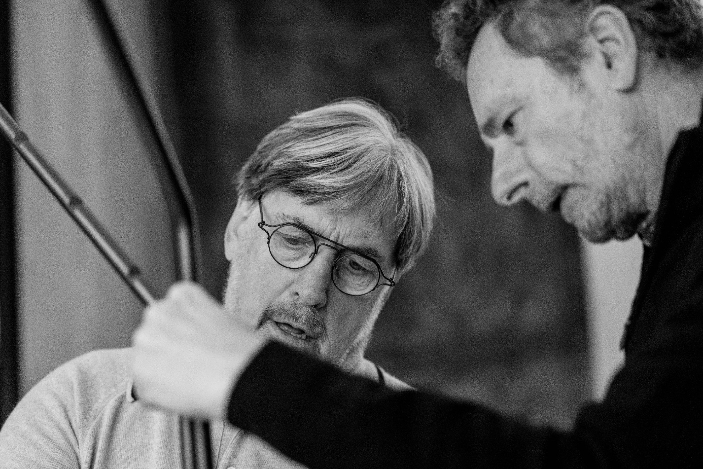
Our AWARDS

Our additional INITIATIVES

Our PARTNERS
in AFRICA

Our PARTNERS
in EUROPE

